EXPERIMENT 26
Clone an existing GitHub repository to your local machine and make
a small change in one of the files.
Tasks:
- Choose an existing public GitHub repository (e.g., your own or a sample repository).
- Clone the repository to your local machine using git clone repository_url&gt;.
- Navigate into the cloned repository directory and open one of the files.
- Make a small edit, such as modifying a line of text or fixing a typo.
- Save your changes.
Step 1: Open the GitHub repository.
Step 2: Copy the repository URL
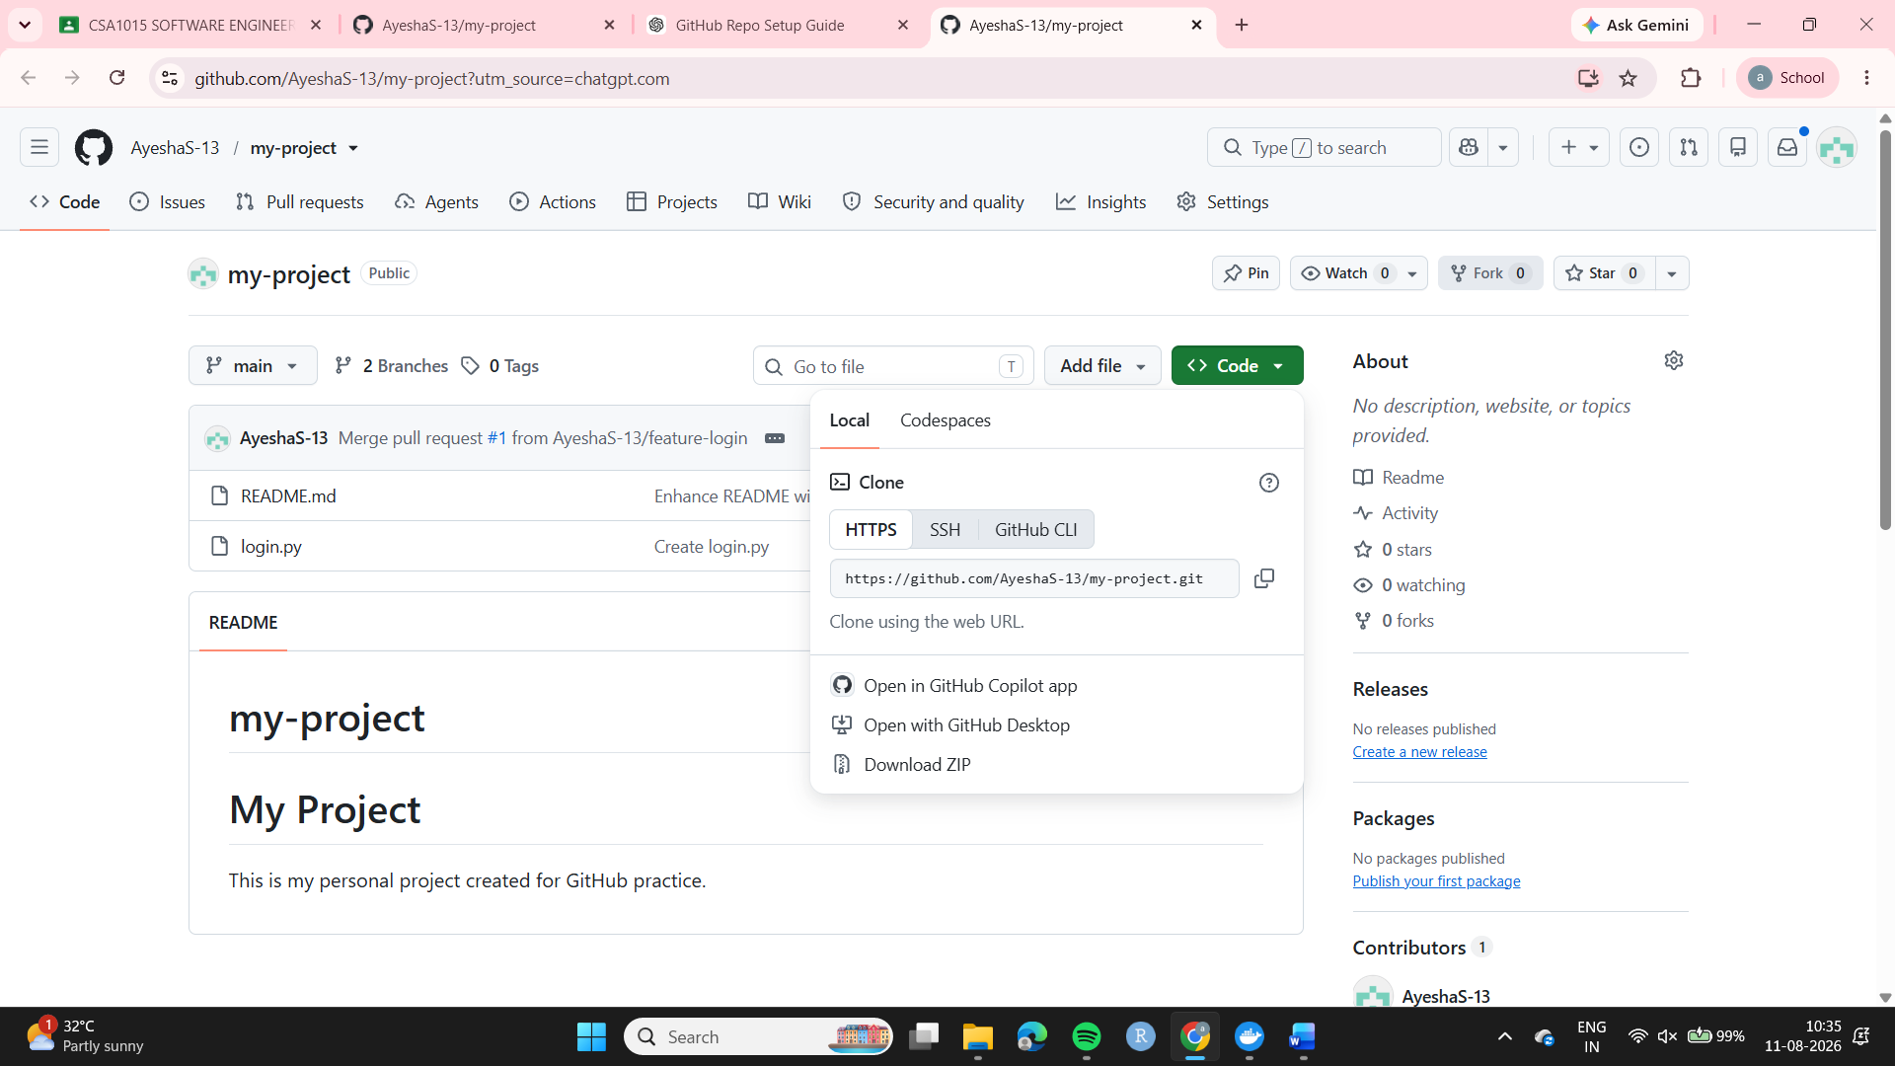
Step 3: Open Git Bash
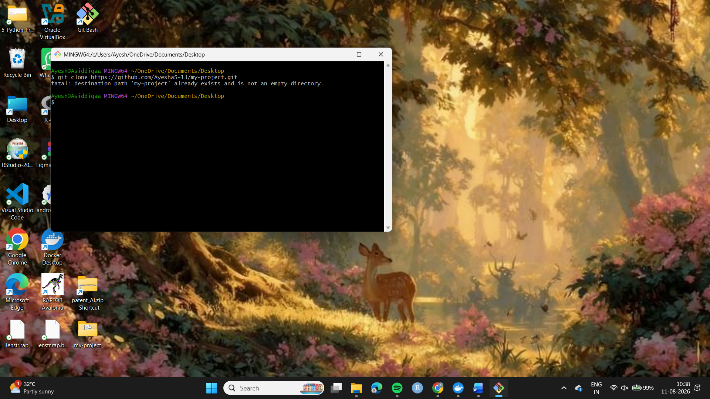
Step 4: Cloned the repository using:
git clone https://github.com/AyeshaS-13/my-project.git

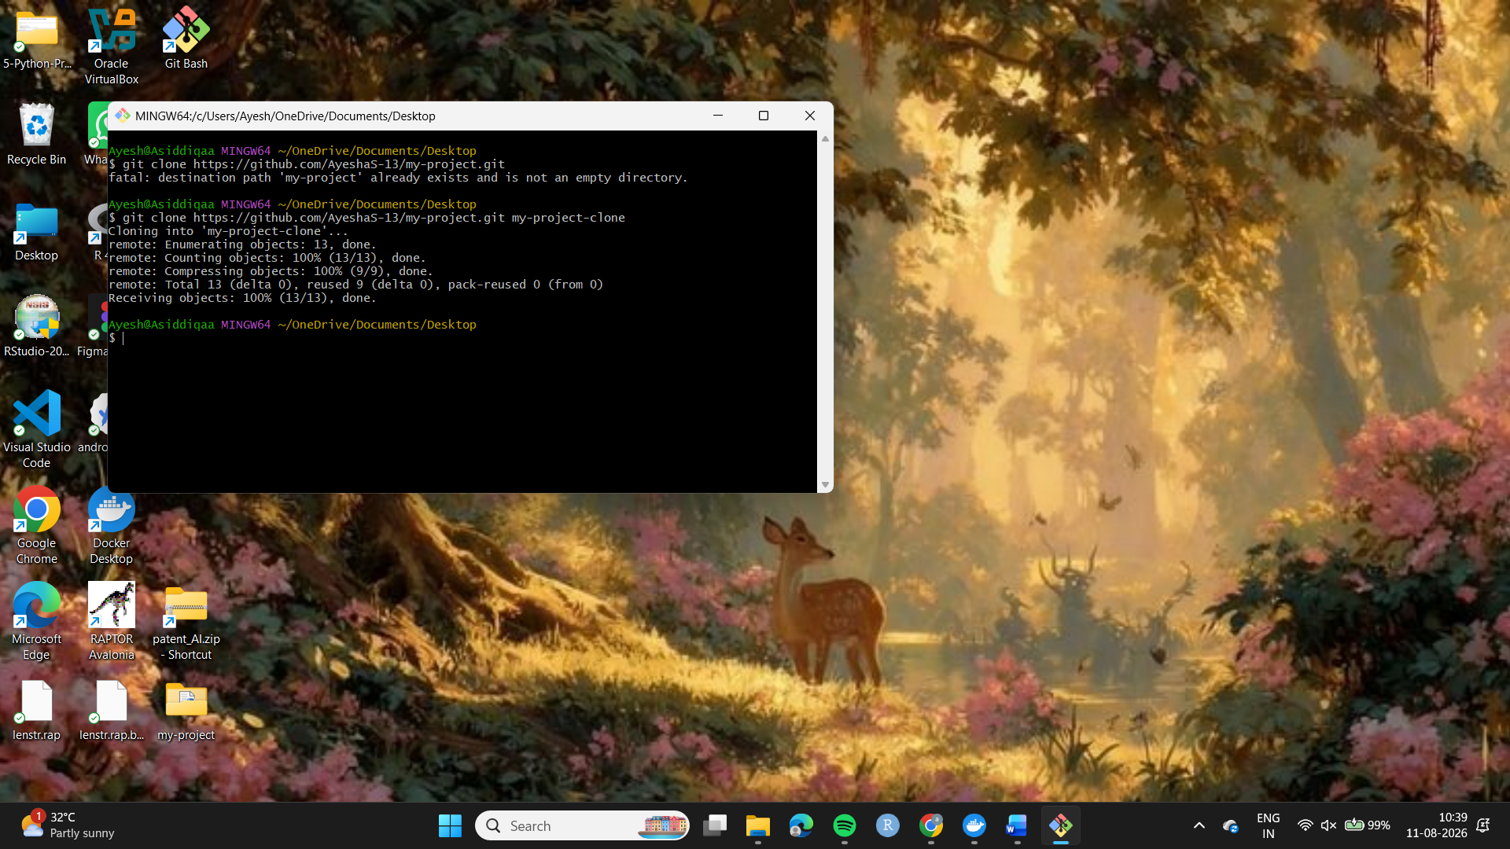
Step 5: Navigated into the cloned repository:
cd my-project
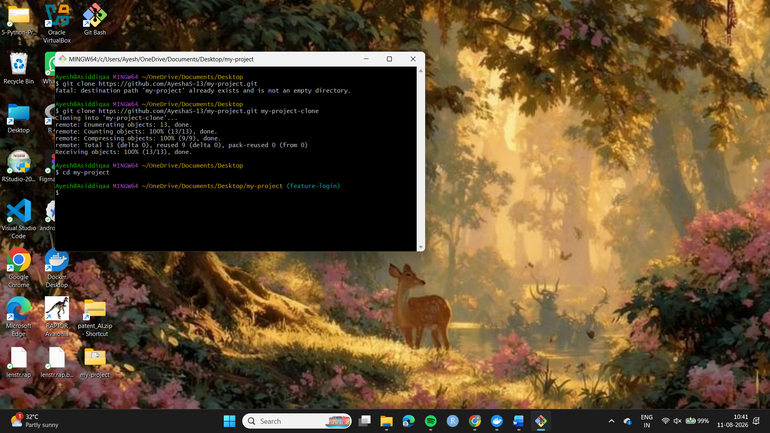
Step 6: Viewed the files using:
ls
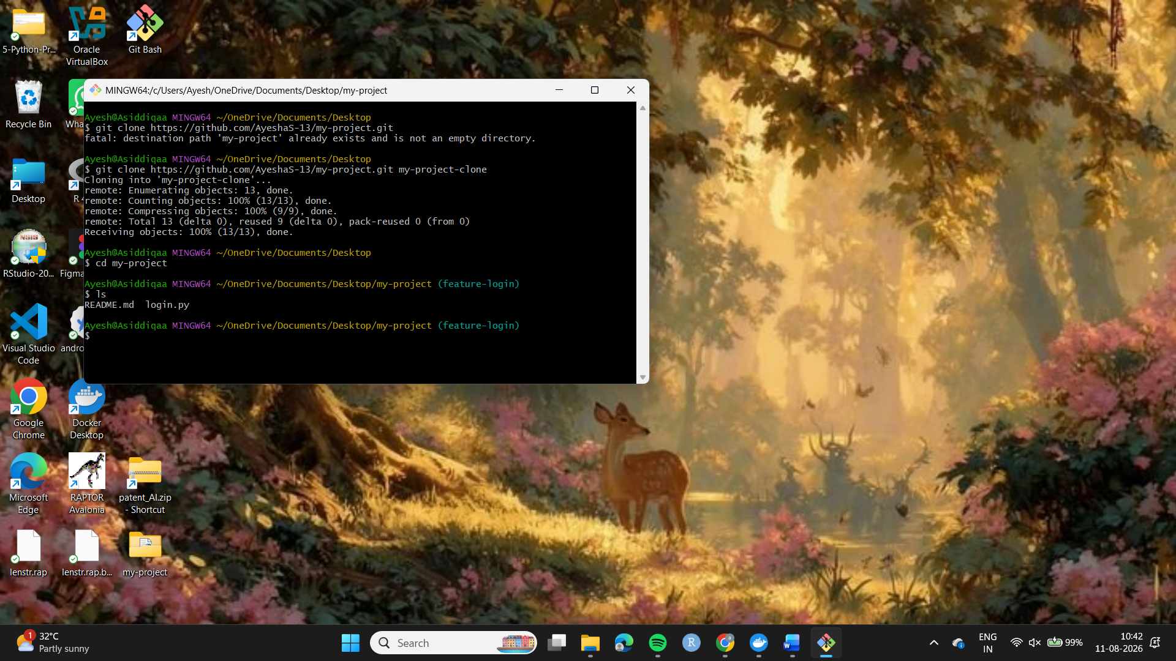
Step 7: Opened README.md using:
notepad README.md
Step 8: Made a small change to the project description.

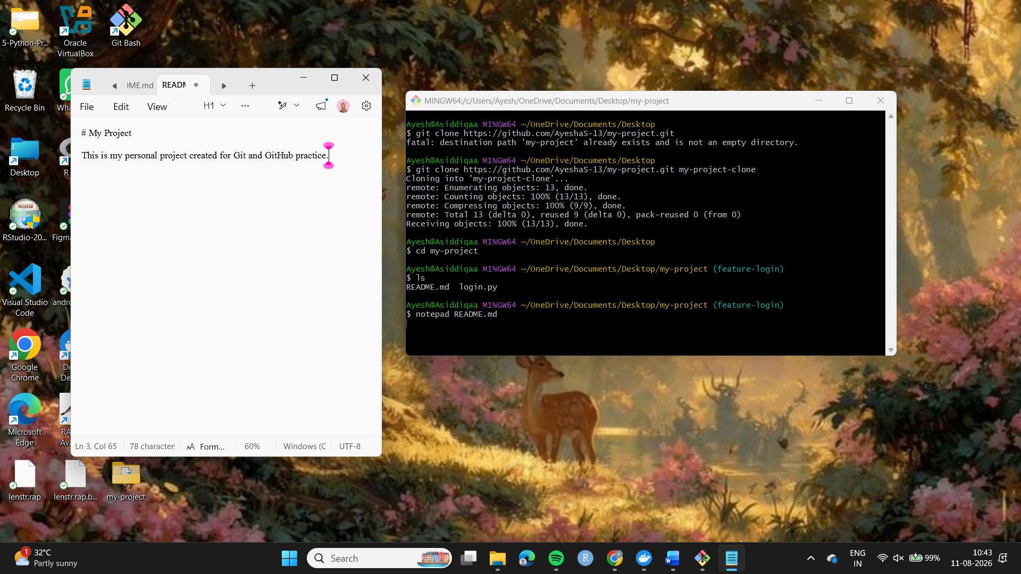
Step 9: Saved the modified file.
Step 10: Verified the modification using:
git status
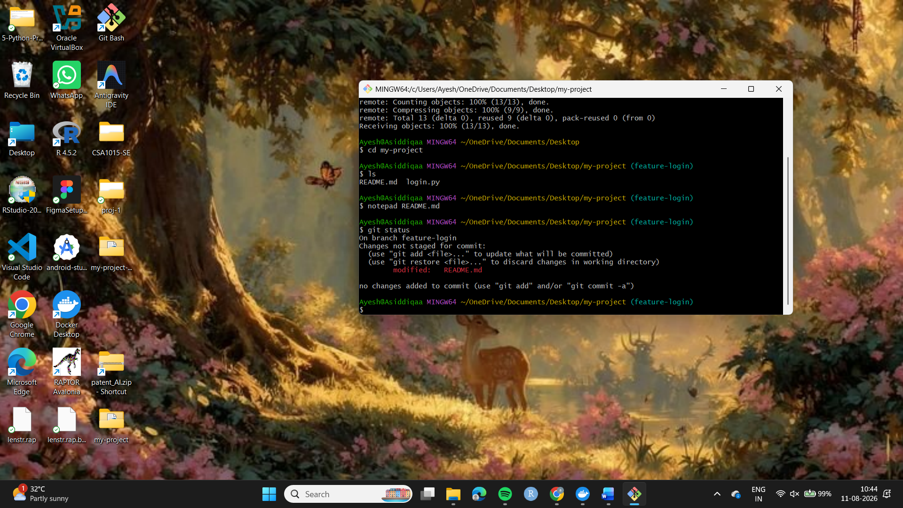
Result
The existing GitHub repository was successfully cloned to the local machine, and a small change was made to the README.md file.

